**POWER BI EXAMPLES**

**HOW TO INSTALL POWER BI DESKTOP TOOL:**

**PRE-REQUISITES: WIN 7 OR HIGHER. 32bit OR 64bit. 4 GB RAM OR HIGHER**

**DOWNLOAD LINK**: <https://aka.ms/pbiSingleInstaller>

CHOOSE ANY ONE FILE FROM ABOVE LINK [Either 32 bit or 64 bit] > DOWNLOAD.

DOUBLE CLICK ABOVE DOWNLOADED FILE > INSTALL > ACCEPT LICENSING TERMS > INSTALL.

(RESTART YOUR COMPUTER)

**ITEM #1: HOW TO DESIGN POWER BI REPORTS [BASIC EXAMPLE - 1]**

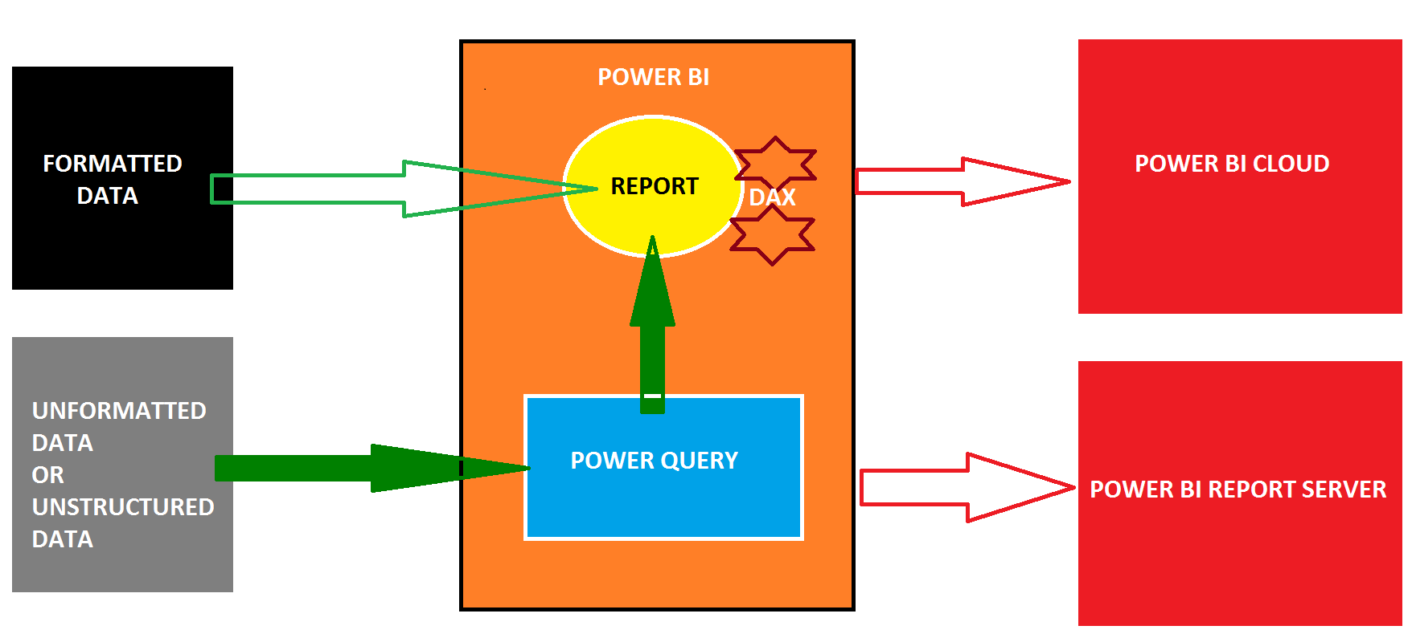

STEP 1: WINDOWS APPS > SEARCH > TYPE : "**POWER BI Desktop**" > CLICK TO LAUNCH POWER BI

THEN YOU SEE ONE WELCOME SCREEN. CLOSE THIS.

THEN WE SEE ONE POWER BI DESIGNER INTERFACE.

HOME RIBBON > **GET DATA** > EXCEL > BROWSE "SALES" EXCEL FILE > SELECT SHEET > **LOAD**.

THIS DATA IS LOADED INTO A **TABLE** INSIDE AN INTERNAL POWER BI DATABASE: "**IN-MEMORY XVELOCITY VERITPAQ DATABASE**". THIS DATABASE IS TEMPORARY, IN MEMORY.

STEP 2: TO VERIFY THE IMPORTED TABLE DATA:

FROM HOME RIBBON > LEFT SIDE : VERITICAL PANE : 2ND BUTTON : **DATA**.

TO GO BACK TO REPORT SCREEN : HOME RIBBON > LEFT SIDE : VERITICAL PANE : 1ST BUTTON

STEP 3: HOW TO DESIGN A BASIC **REPORT** IN POWER BI?

A POWER BI REPORT CAN BE GENERATED FROM ANY DATA SOURCE (FILE, DATABASE, APP...).

EACH POWER BI REPORT CAN BE DIVIDED INTO MULTIPLE "**PAGES**". JUST LIKE EXCEL "SHEETS".

CLICK @ PAGE 1 > FROM VISUALIZATIONS PANE (RIGHT) > SELECT **TREEMAP** VISUAL (18th).

THEN ONE EMPTY TREEMAP VISUAL IS AUTO ADDED TO THE CANVAS (WHITE DESIGN WINDOW)

SELECT THE TREEMAP FROM CANVAS (LEFT: WHITE SCREEN)> FROM "FIELDS" PANE (RIGHT) > CHECK THE BOXES @ *COUNTRY*, *SALE 2020*

THEN SELECT THE TREEMAP VISUAL FROM THE CANVAS (WHITE SCRREEN) > EXPAND THE SIZE.

SELECT TREEMAP > BELOW VISUALIZATIONS PANE (MIDDLE WINDOW) > FORMAT BUTTON >

**LEGEND** : ON: SET TEXT SIZE [TO CONTROL OR HIGHLIGHT CATEGORY] **DATA LABELS**: ON: SET TEXT SIZE [TO REPORT SUMMARY VALUES = *TOTAL SALES*] **CATEGORY LABELS**: SET TEXT SIZE [TO REPORT CATEGORY TEXT=*COUNTRY* NAMES

Purpose of Legend : To Highlight or Select the required Category Items (Country).

Each Category Item forms a "Data Point". [Box; Ex: Germany Data Point, India Data Point...]

**STEP 4**: WHAT ARE THE OPTIONS TO SAVE POWER BI REPORT LOCALLY [IN OUR COMPUTER] ?

OPTION 1: **PBIX** : SAVES REPORT + IMPORTED DATA APPLICABLE FOR SMALLER, HISTORICAL DATA SOURCES.

OPTION 2: **PBIT** : SAVES REPORT ONLY. NO DATA IS STORED IN PBIT.

APPLICABLE FOR BIGGER, LIVE / ONLINE DATA SOURCES.

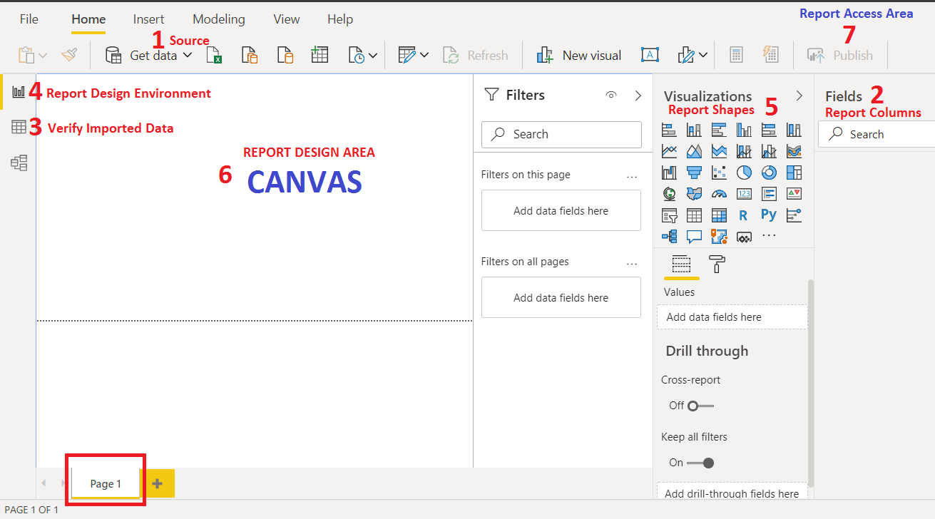

Solution:

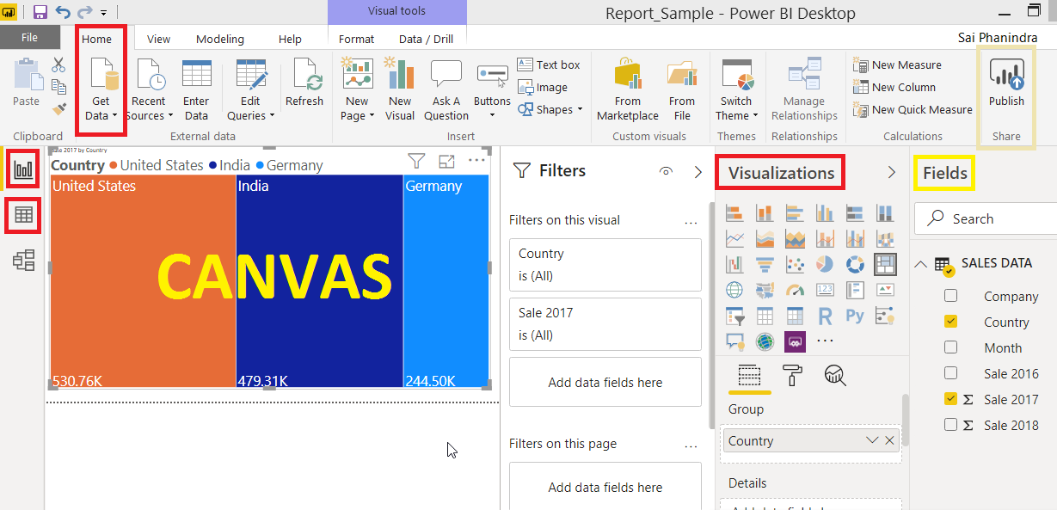

**BASIC TERMINOLOGY FOR UNDERSTANDING THE VISUALS [Example : Treemap, Table, Matrix, etc...] :**

LEGEND : TO CATEGORIZE OR DIVIDE THE VISUAL INTO "DATA POINTS"

DATA LABELS : SUMMARY VALUES FOR EACH CATEGORY. EX: TOTAL SALES @ COUNTRY

TOOLTIP : ADDITIONAL DATA WE SEE WHEN HOVER MOUSE ON A DATA POINT.

FOCUS MODE **: THIS PROPERTY IS USED TO ZOOM A PIRTICULAR VISUAL.**